**Practice practical no:01**

**Usecase diagram**

1. **Hospital appointment system:**

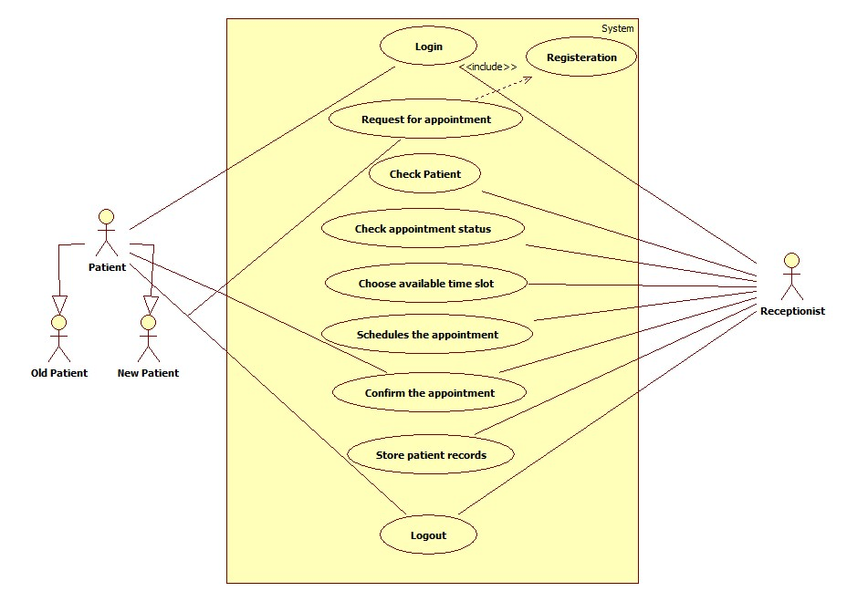

1. **Chatboat System**

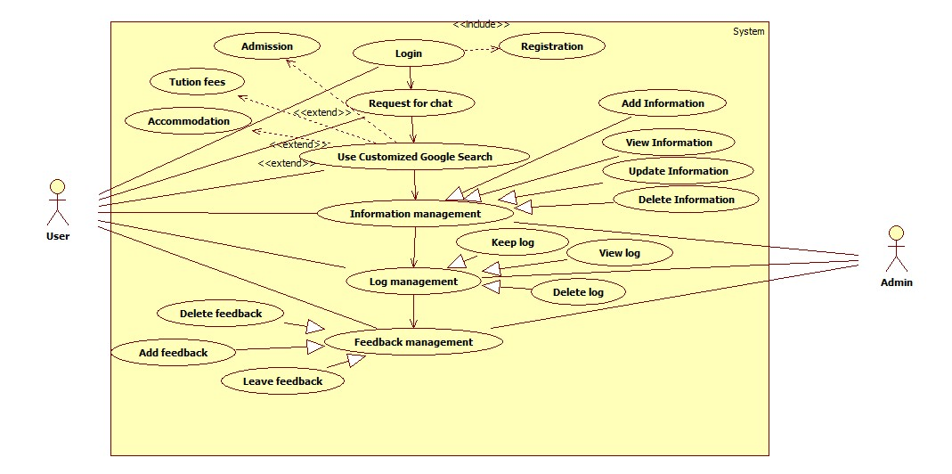

1. **Banking System**

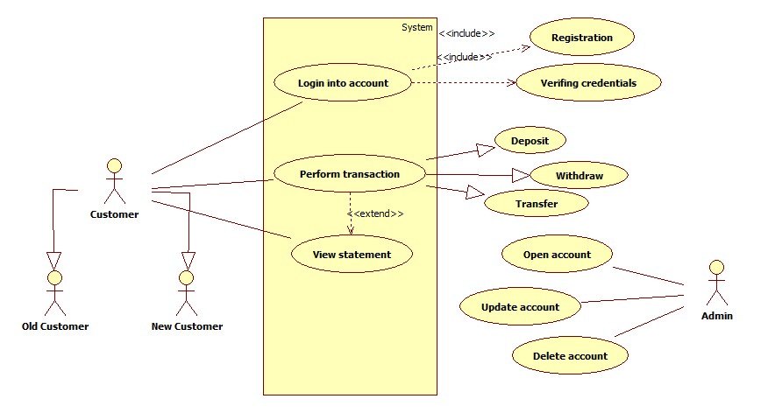

1. **Chatboat system**

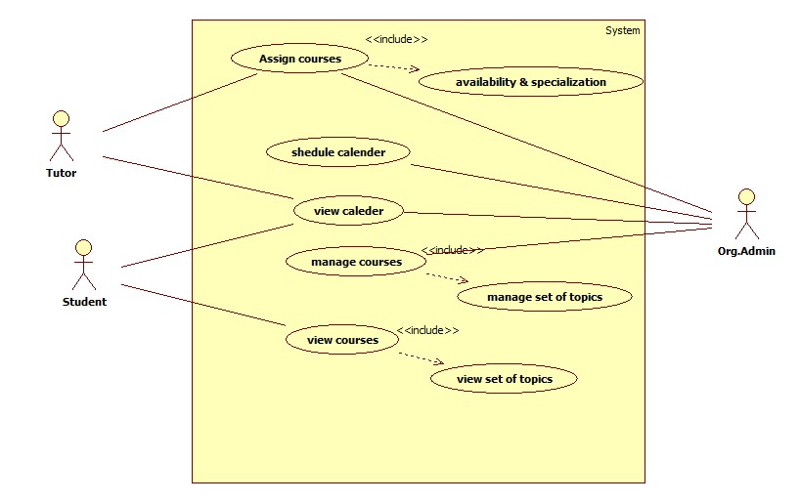

Use Case Diagram specification

|  |  |
| --- | --- |
| Use Case ID: | HS1 |
| Use Case Name: | Healthcare System |
| Created By: | Sayali Kamble |
| Date Created: | 07/08/2019 |

|  |  |
| --- | --- |
| Actor: | User,Admin |
| Description of use cases: | Allow user to login  Allow user to register  Allow |
| Preconditions: | The user should be authenticated(Login) |
| Postconditions: | Patient makes appointment |
| Includes: | Registration  Verifying credentials |
| Assumptions: | Participation of Doctor |

Use Case Diagram specification

|  |  |
| --- | --- |
| Use Case ID: | BS1 |
| Use Case Name: | Banking System |
| Created By: | Sayali Kamble |
| Date Created: | 07/08/2019 |

|  |  |
| --- | --- |
| Actor: | User,Admin |
| Description of use cases: | Allow user to login  Allow user to perform transaction  Allow user to view statement |
| Preconditions: | The user should be authenticated(Login) |
| Postconditions: | Perfom transaction  View statement |
| Extends: | View Statement |
| Includes: | Registration  Verifying credentials |
| Assumptions: | User has authenticated account. |

Use Case Diagram specification

|  |  |
| --- | --- |
| Use Case ID: | CB1 |
| Use Case Name: | Chatboat System |
| Created By: | Sayali Kamble |
| Date Created: | 07/08/2019 |

|  |  |
| --- | --- |
| Actor: | User,Admin |
| Description of use cases: | Allow user to login  Allow user to chat  Searching  Information Management  Log Management  Feedback Management |
| Preconditions: | The user should be authenticated(Login) |
| Postconditions: | Allow chat  Inform user if not available |
| Extends: | Admission  Tution Fees  Accomondation |
| Includes: | Registration |
| Assumptions: | User should be connected to internet |